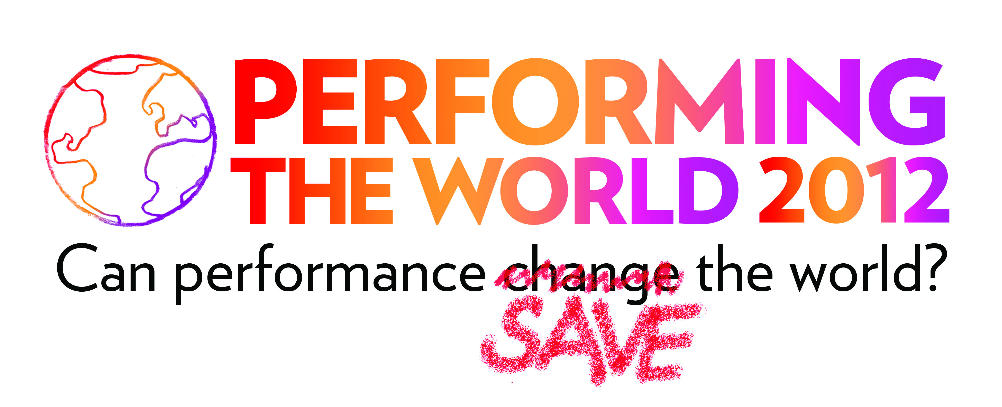

Performing the World 2012 will be a marathon “performance of conversation” with people from all over the world — scholars and researchers; educators, therapists, social workers, youth workers; doctors and other health workers; theatre, applied theatre and other performance artists; social activists and community organizers; business leaders and philanthropists; film, video and media creatives; and others.
PTW will be held at the All Stars Project’s performance and development center on 42nd Street in New York City. See http://www.performingtheworld.org/
Address: All Stars Project, 543 West 42nd Street, New York, NY 10036

Report of Lecture with Video Presentation held by EVA BRENNER (Vienna/Austria) on 07/10/2012 at the ALL STARS PROJEKCT Conference Headquarters

“TRANSFORMANCE” _ Political Theater at Breaking Points
from Avantgarde to Sociotheatrical Performance to “Transformance”
Performance Workshop (30 min.) & Video Lecture (60 min.) - a presentation of 90 minutes in 2 sections

Preliminiaries:
In the spring of 1998 PROJEKT THEATER-Vienna-New York (founded in 1991) opened its first STUDIO in the city-center bohemian 7th district : a white cube open-space for “Poor Theater” and avant-garde performance works. From 1998-2003 the company established a sizeable body of work based on Beckett’s “Endgame” and contemporary women’s works (Streeruwitz, Hahn or Polish Hannah Krall (www.experimentaltheater.com). By 2003, the company had acquired esteem as classical left avant-gardist theater with public and moderate private funding. Following on the heels of a series of cut-backs in funding as part of at neo-liberal “Theatre Reform” of the city’s governing Social-Democrats the group moved into an empty storefront space, changed its performance mission and practice to sociotheatrical experiments with theatrical cooking-chows of artists and migrants, intercultural wedding-parties in local restaurants, fiestas and street procession in the community. The group began to use public space and create active networks in the neighbourhood, including small businesses, local NGOs and cultural, social and refugee organizations. Most recently the group lost another junk of funding and is now working flexible in multiple open spaces in and with varying cooperative partnerships throughout the city and formulating a new concept of “Transformance” as opposed to avant-garde, postmodern and sociotheatrical performance works. This redefinition of what is political “performance” at the height of our days, addressing the crisis of culture as part of larger civilization crisis and searching for new audiences in new spatial settings, theatrical frameworks and working formats were discussed by in the lecture.

The lecture was accompanied by a video-showing of the recent edition of ON AXIS, sociotheatrical theater procession in the 7th Vienna district (June 2012).

1.
“From Theater to Performance to Transformance” – a 30 min. Performance workshop based on the BUTCHERIE`’s second phase of work as developed from political avant-garde performances to sociotheatrical experiments to a new concept of “transformative” Performance work in the communities (2004-2012)

The workshop was based on a short scene from a Heiner Müller play (The Task) and offered three steps of performance improvisation to be executed by the group, included warm-up techniques, text-reading, choral reading and a group finale. It led to a discussion with video-showing as outlined below.

2.
Lecture-demonstration was a presentation of our recent development of a concept for “TRANSFORAMNCE”, laid out in a “Transformance Manifest” (November 20111) and based on sociotheatrical practice of the avant-garde theatre troupe in Vienna/Austria, PROJEKT THEATER STUDIO (1998-2012) with intercultural performances, site-specific works in public space, and sociotheatrical experiments in local communities including of artists, migrants, refuges and small businesses. (See www.experimentaltheater.com)

“Transformance” as new performative genre remixing (artistic) „performance“ and (social) „transformation“
- is a new activist performance-genre based on my recent intercultural work, fusing strategies of political „theater“ and contemporary avant-garde „performance“ with conscious acts of social „transformation
- developed since 2003 at the alternative art-center „BUTCHERIE“ (Vienna) by way of progressing from classical avant-garde theater into community-based group; socio-theatrical wors include migrant street-performances, cooking-shows, fiestas, and processions effecting „transformation“ in ordinary people’s lives.
- associates with new social movements (e.g. World Social Forum) acting in resistance to neo-liberalism, globalization, financial crises, dismantling of welfare states, cutbacks in social benefits, culture, and education as threats to democracy.
- is led by engaged artists in solidarity with amateurs for/in disadvantaged communities (migrants, refugees, unemployed, homeless, or elderly) aiming at social empowerment of producers and participants.
- proposes cross-cultural, cross-discipline performances situated between art, theater, communication, and activism in/for local communities.
- Presents artworks in public spaces to revitalize declining urban landscapes.
- targets new, non-theater-going audiences and synthesizes pluralism, diversity, interculturalism, and modes of active participation.
- calls for independent economic models outside of traditional (party) politics in the interest of local communities.
- challenges artists to move from mainstream institutions towards the support of social movments to open channels for social communication, political awareness, and active participation! (Sommer, Werlhof)
- formulates tasks for a „theater against crisis“, an activist solidarity-network of equal cultural „spectactors“is a „social theater/art for all people“!

By reviewing these and realted issues, socio-political-cultural impacts of “Transformance” as a new performative practice was discussed.

Biography:
EVA BRENNER, Ph.D., Dr. Phil. (A/USA) is an experimental theater director and scholar who studied theater science, design, and art history in Vienna (A), and Performance Studies (with R. Schechner) at NUY while working Off-Off B’way and in grass-roots movements (1980’s). Returning to Austria in the early 90s, she founded the experimental Projekt Theater Vienna-New York/BUTCHERIE for avant-garde and socio-theatrical performances uniting artists, non-professionals, migrants, refugees, and local communities.

